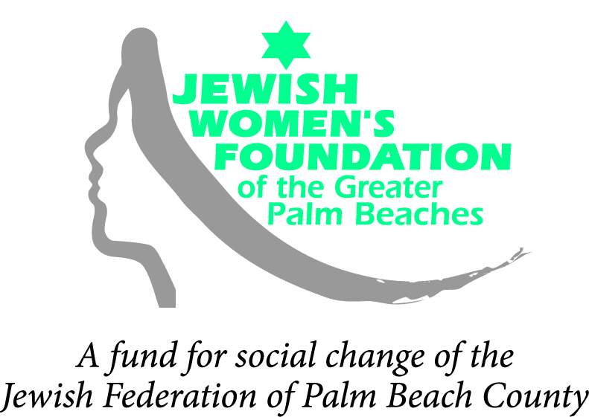
4601 Community Drive | West Palm Beach, FL 33417-2760 | 561-242-6673

2012-2013 GRANT APPLICATION PROCESS AND TIMELINE FOR PROPOSALS
    - Proposals must be submitted on the Jewish Women's Foundation (JWF) grant application form, which can be obtained by downloading the file or by calling our office at (561) 242-6604.Click here to download the Issue Awareness Grant application. Click here to download the Signature Grant Letter of Intent.
    - To be considered, fully completed applications and all supporting documentation required must be included. We will contact you if additional information is necessary.
    - Letters of Intent (required for Signature Grants only) must be received in the JWF office via e-mail by 5:00 p.m. on Friday, August 19, 2011. (Please complete the form provided in the Grant Application Information section below.)
    - The JWF will review Letters of Intent and notify applicants by Friday, September 23, 2011 whether or not to sumbit a full grant proposal.
    - Proposals for both Signature Grants and Issue Awareness Grants must be received in the JWF office by 5:00 p.m. on Friday, November 4, 2011.
    - Proposals are reviewed and recommended by our Grants Committees to our Board of Trustees, which makes final funding determinations.
    - Applicants will be notified of the Trustees' decision by letter. Grants will be announced by the end of March 2012.
    - Signature grantees are required to submit an interim progress report by October 19, 2012. A final report is due by the end of April 2012.
    - Issue-Awareness grant award recipients will receive funding by the end of July 2012.
    - Signature grant award recipients will receive half of their funds by the end of July 2012 and the remainder by the end of October 2012, as long as the interim evaluation goals and timetables are being met.
    - Site visits by JWF trustees may be conducted prior to grant determinations or once a grant has been awarded, or both.

Please submit completed proposals to:
Jewish Women’s Foundation of the Greater Palm Beaches
Grants Committee
4601 Community Drive
West Palm Beach, FL 33417-2760
We are happy to answer your questions. Please contact the JWF office:
(561)242-6673 or jwf@jewishpalmbeach.org.

