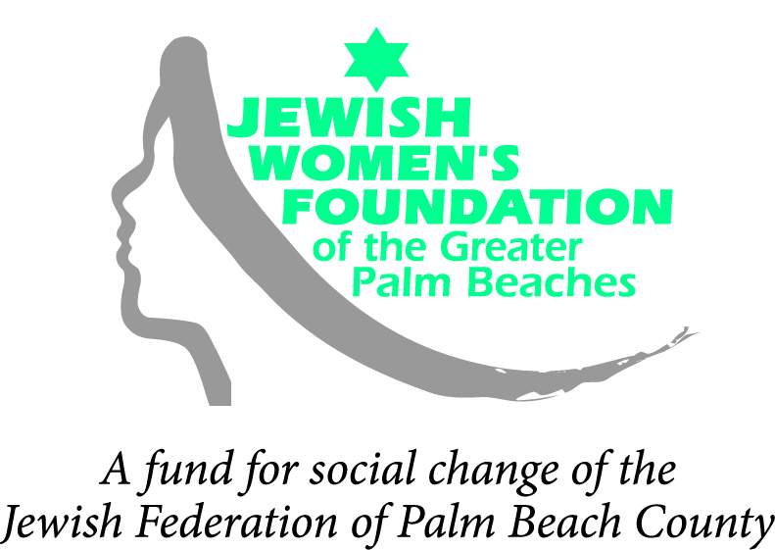
4601 Community Drive | West Palm Beach, FL 33417-2760 | 561-242-6673

ESTABLISHING “THE FIT”
The Jewish Women’s Foundation (JWF) funds “bi-focally” through both a “gender lens” and a “Jewish value lens.”
We examine each proposal both on the merits of its fit between the specific project and JWF’s vision and priorities, and the extent to which your organization’s overall support of women and girls is compatible with our founding values and organizing principles.
Please take the time to carefully review our vision, mission, granting format and annual funding priorities, and our eligibility policy to determine if your organization, program, project or initiative meets the JWF’s criteria.
Call (561) 242-6673 if you have any questions regarding "the fit."

ELIGIBILITY
    - The Jewish Women’s Foundation (JWF) funds only organizations with their own 501(c)(3) tax status or with a fiscal agent who is a 501(c)(3). Legal opinion letters of non-profit status are not sufficient.
    - The project/program for which you are requesting funding must be aligned with the JWF’s mission of social change for Jewish women and girls.
    - We do not fund established, ongoing social service programs.
    - We do not fund political campaigns or organizations such as PACs.
    - Priority is given to initiatives in Palm Beach County and Israel; however, we will consider proposals concerning Jewish women and girls in other areas of the world.
    - We do not make grants to individuals, make loans, award scholarships or participate in capital campaigns.
    - We do not buy tickets for special events.
    - Previous funding does not guarantee continued funding, nor does it preclude future funding.

