Dear Grant Seeker:
We are pleased to announce the 2012-2013 funding cycle of the Jewish Women’s Foundation Issue Awareness Grants. The Jewish Women’s Foundation is a grant making organization rooted in Jewish values whose mission is to effect social change on behalf of women and girls. The Jewish Women’s Foundation (JWF) funds “bi-focally” through both a “gender lens” and a “Jewish value lens.”
WHAT ARE ISSUE AWARENESS GRANTS
“Issue-Awareness” grants are grants for programs in the Greater Palm Beach area only. They are specifically designed to inform or activate the Jewish community, the general public, and/or professionals about issues and best practices of importance for Jewish women and girls.
These funds can be used to convene educational meetings, to disseminate information on issues or research findings; to educate professionals, Jewish girls and/or their parents about the particular challenges and needs of Jewish women and girls; and sponsor innovative community-wide events addressing these critical issues.
GRANT GUIDELINES
We ask that your program involve multi-generations and that you collaborate with one or more organizations.
We invite you to be creative in the planning of this program.
We invite proposals that address these broad issues: domestic violence, teen dating abuse, grandparents in crisis, cyber bullying, Jewish identity and harassment and multi-generational issues.
These grants range from $500 to $7,500 for programs.

GRANT APPLICATION
The Issue-Awareness grant application requires short statements describing the organization’s mission, the proposed activity, goals, “fit profile,” (how the proposed activity fits with the JWF vision/mission) and what constitutes success.
We examine each proposal both on the merits of its fit between the specific project and JWF’s vision and priorities, and the extent to which your organization’s overall support of women and girls is compatible with our founding values and organizing principles.
Please take the time to carefully review our vision, mission, granting format and annual funding priorities, and our eligibility policy to determine if your organization, program, project or initiative meets the JWF’s criteria.
    - The Jewish Women’s Foundation (JWF) funds only organizations with their own 501(c)(3) tax status or with a fiscal agent who is a 501(c)(3). Legal opinion letters of non-profit status are not sufficient.
    - The project/program for which you are requesting funding must be aligned with the JWF’s mission of social change for Jewish women and girls.
    - We do not fund established, ongoing social service programs.
    - We do not fund political campaigns or organizations such as PACs.
    - We do not make grants to individuals, make loans, award scholarships or participate in capital campaigns.
    - We do not buy tickets for special events.
You may mail your completed application to the attention of: Jewish Women’s Foundation,
4601 Community Drive, West Palm Beach, FL 33417; you can fax it to Wendy Weiss at
561-681-3504; or you can e-mail it to Wendy.Weiss@JewishPalmBeach.org.

ISSUES AWARENESS GRANTS 2012-2013 TIMELINE
Deadline for submission of grant application is Friday, November 4, 2011.
Notification to agencies of grant approval is Friday, March 30, 2012.

Thank you,
Lynn Kaston
Issue Awareness Chair

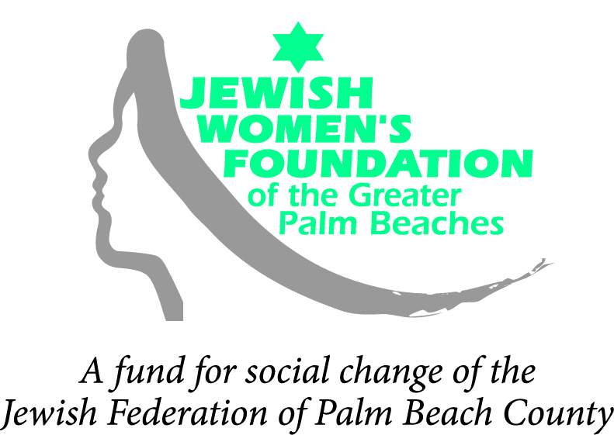

ISSUE AWARENESS GRANT APPLICATION FORM
Please complete all questions in the space provided. The completed application should be no more than three (3) pages. Completed final grant applications are due in the Jewish Women’s Foundation office no later than 5:00 pm on Friday, November 4, 2011. You may hand-deliver, mail or e-mail completed grant applications and attachments. If you submit by email, please indicate the number of pages transmitted. Please email the original signed grant application and any accompanying documentation, such as brochures and annual reports. We cannot accept late applications.

TITLE OF THE PROGRAM:

Organization: Year Founded

Address: Phone:

Email Address: Email Address:

Program Contact: Executive Director:

Date: Date:

Is your organization a 501(c)3 ? Yes No
If not, what organization will serve as your fiscal agent?

Number of people served How many are Jewish females?

Number of board members How many are Jewish females?

Budget for the program $ Amount requested $

What is the mission of your organization?

What needs or issues does this project/program seek to inform about or redress?

Please provide a brief summary of the issue awareness educational project/program for which you are seeking JWF funding. Is it a new or ongoing program?

How does this relate to JWF priorities?

Age(s) of the target population(s) for program/ project:
8-17 18-22 22-30 31-55 56-75 75+
How will you measure the success of the project?

Projected Program Expenses: $ for

Program Income: $ from (i.e., ticket sales, etc)

Do you anticipate requiring additional funding for the program/project? No Yes

If you do, please list the sources, including the amounts requested/granted, and whether revenue is secured or pending.

What will constitute success for this project? How will your success be measured?

