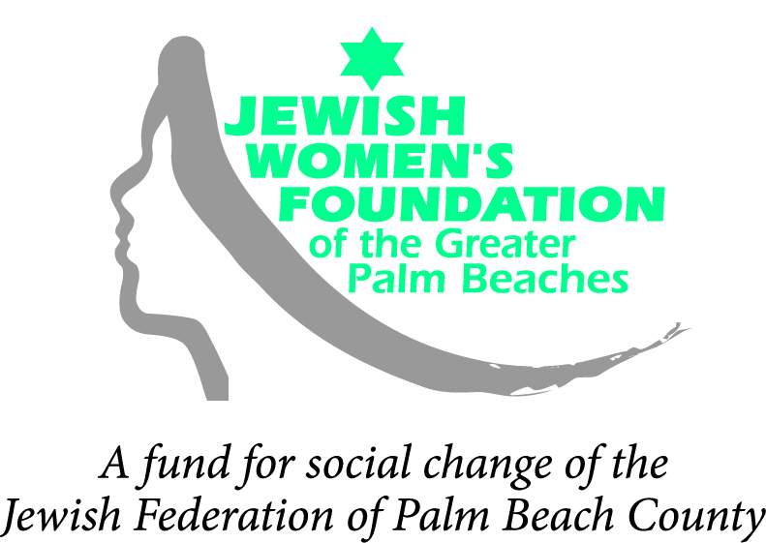

Signature Grant Application Form
Please complete all questions below in the space provided. Applications with all required attachments are due in the Jewish Women’s Foundation office no later than 5:00 p.m. on Friday, November 4, 2011. You may hand-deliver, mail or e-mail completed grant applications and attachments. If you submit by e-mail, please indicate the number of pages transmitted. Please mail the original signed grant application and any accompanying documentation, such as brochures and annual reports. We cannot accept late applications.
GRANT TITLE:

ORGANIZATION: Year Founded:
Address:
Phone:
E-mail: Website:
Contact: Executive Director:
Signature: Signature:
Is your organization a tax-exempt 501(c)(3)? Yes No
If not, what organization will serve as your fiscal agent?

[Please include a letter of authorization from your fiscal agent and a copy of their 501(c)(3)]
Number of board members: How many are Jewish females?
Number of senior staff: How many are Jewish females?

Amount requested: $ Total project budget: $
Amount requested from other sources: $
Organization’s annual operating budget: $
Length of project: 1 year 2 years 3 years 4 years 5 years
Geographic focus:
Palm Beach County U.S. Israel Other (specify):
SIGNATURE GRANT APPLICATION FORM
PROPOSAL ELEMENTS
Please write and attach a proposal narrative (maximum of five [5] pages), incorporating the following points:
- Organizational overview: What is your organization’s mission? Provide a brief overview of your ongoing programs. Who is impacted by your organization’s work (be specific about demographics such as gender, religion, age, sexual orientation, race and people with disabilities)?
- Problem statement: What needs or issues does your proposed activity address?
- Description of Activity: Describe the initiative for which you are seeking funding. Is this a new or ongoing activity in your organization? How does this activity respond to the needs you have identified? In what ways will this activity further inform or educate about the issues being addressed? In what ways will this activity affect attitudes, policies and/or practices that adversely effect women and girls?
- Activity Fit: In what ways does this proposal initiative advance the vision and mission of the JWF? How does it fit with our funding goals?
- Leadership: Who is responsible for this initiative? Who is involved in designing this activity? Include a brief paragraph summarizing the qualifications of key individuals involved in carrying out the plans outlined in this request.
- Collaboration Partners: With which organizations, if any, are you collaborating? Describe the roles of each organization.
- Goals, Timetables and Objectives: What changes do you anticipate in the lives and conditions of women and girls as an outcome of this activity? Discuss the overall goals, timetables and specific, measurable objectives for the project.
- Evaluation: How will you measure the success of the project for which you are seeking support? What questions will be addressed? How will you define success? Who will be involved in evaluating the project – staff, board members, constituents, community and consultants? How will the evaluation results be used?
- Additional Funding Resources: Do you plan to seek funding for this project elsewhere? If you anticipate receiving additional funding for this initiative, please list the sources of support, including amounts requested/granted and whether revenue is secured or pending. Please itemize sources by collaborative partners, government, foundations, corporations, Jewish Federations and individuals.
- Funding Status and Plans: How will the project be maintained after support from the Jewish Women’s Foundation is discontinued? If this grant is not fully funded, can you still proceed with this program?
- Signature Grant Budget Form: Please use the Program/Project Budget Form to provide the Jewish Women’s Foundation with complete information about your grant’s projected expenses and revenues.
SIGNATURE GRANT BUDGET FORM
The purpose of this budget form is to provide the Jewish Women’s Foundation with complete information about your project’s projected expenses and revenues. You may scan or photocopy this form, reproduce it on your computer, type your own budget using these headings or print legibly. If you already prepare organizational and project budgets that approximate this format, please feel free to submit them in their original forms. Below is a listing of standard budget items. Please add categories where necessary.
Please indicate the time period this budget covers: __________ to __________
I. GRANT | A. Total Expenses | B. Amount Requested
Salaries (specify FT/PT)
Staff Training
Payroll Taxes
Fringe Benefits
Consultants and
Professional Fees
Insurance
Travel
Equipment
Supplies
Printing and Copying
Telephone and Fax
Postage and Delivery
Rent
Utilities
Evaluation
Marketing
Other (specify)
TOTAL EXPENSES

II. SOURCES OF REVENUE | C. Committed Revenue | D. Pending Revenue | E. (C+ D)  Total Revenue
Grants/Contracts/Commitments
Government*
Foundations*
Corporations*
Federation*
Individuals
Earned income
(admission charges, other)
In-kind Support (indicate source)
Other Revenue (specify)
TOTAL REVENUE
*Please provide a list of specific funders.
III. PROGRAM/PROJECT FUNDS NEEDED
Total Expenses in excess of Committed Revenue (A-C)
Total Expenses in excess of Total Revenue (A-E):
IV. AMOUNT REQUESTED – Must match Total Requested (B)

