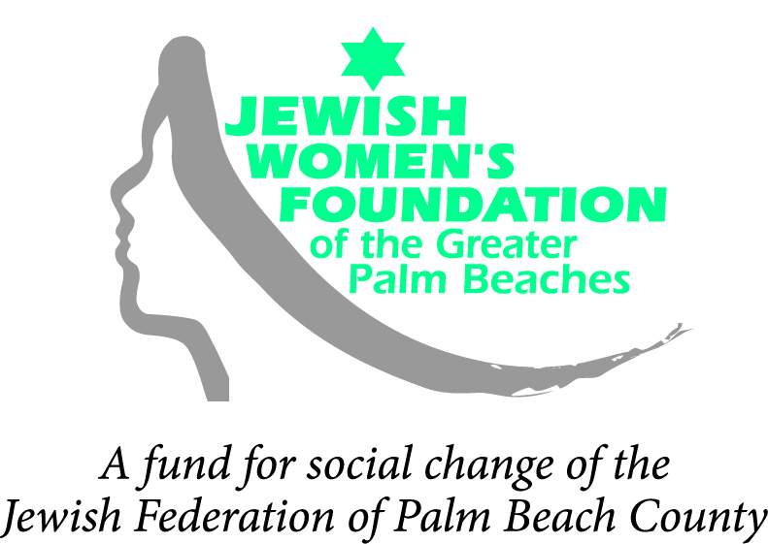

Letter of Intent

Letters of Intent are due in the Jewish Women’s Foundation office by 5:00 p.m. on August 19, 2011. Complete this form using a 10-point or larger font, and use no more than three (3) pages to answer the questions. Submit your Letter of Intent by e-mail to: jwf@jewishpalmbeach.org.

PROGRAM/PROJECT TITLE:

ORGANIZATION:

GRANT AMOUNT REQUESTED: $
Estimated Project Cost: $
Total Organizational Budget: $

1) Organization’s Address; Website; Contact Person; Title; Telephone; E-mail:

2. Is your organization a tax-exempt 501(c)(3)? Yes No If not, which organization will serve as your Fiscal Agent? [Please attach a Letter of Authorization from your fiscal agent and a copy of their 501(c)(3).]

3. Brief Organization History, Activities and Accomplishments:

4. Concept for Project:

5. Briefly provide any relevant statistical data or concrete examples demonstrating the need for this particular project:

6. How will this project effect social change for Jewish women and girls?

7. Target Populations and Age Range(s):

8. Program Goals:

9. Timetable:

10. Expected Measurable Objectives and Outcomes:

11. How will you evaluate the project to determine if your objectives and outcomes were met?

12. Other funding sources you have approached:

E-mail your Letter of Intent to The Jewish Women’s Foundation of the Greater Palm Beaches at jwf@jewishpalmbeach.org

